Exp.No:29
29. Morphological operations based on OpenCV using Erosion technique.

Aim:
To perform the Erosion morphological operation on an image using OpenCV.
Procedure:
- Read the input image (Girl.jpg).
- Create a structuring element (kernel).
- Apply the erosion operation using cv2.erode().
- Resize the images for medium-size display.
- Display the original and eroded images.
- Save the output image.
Program:
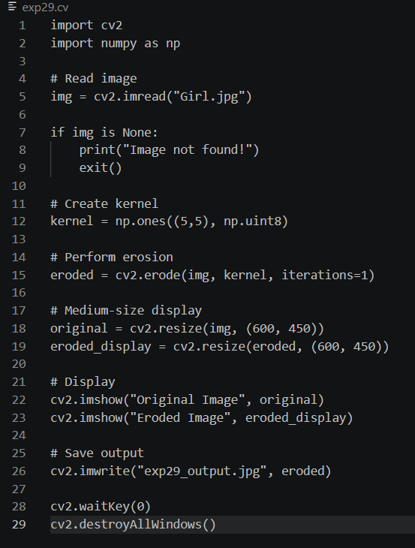

Input:

Output:
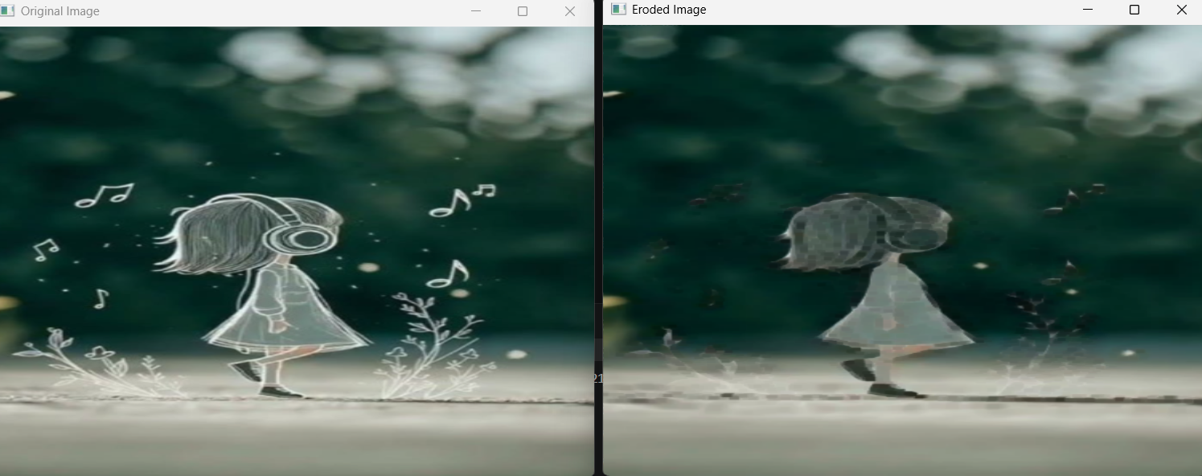

Result:
The erosion morphological operation was successfully performed on the input image. The eroded image was displayed and saved successfully.

